# Connecting to the server and creating a sample file using PuTTY

Open PuTTY and set the host name to [your-solis-id]@gemini.science.uu.nl. Leave the password the same.

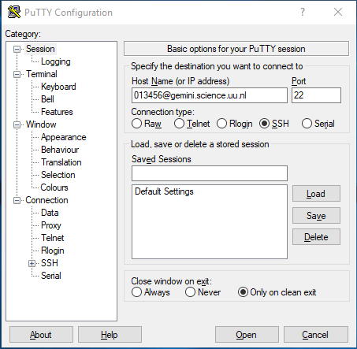

Login using the password for your SOLIS ID

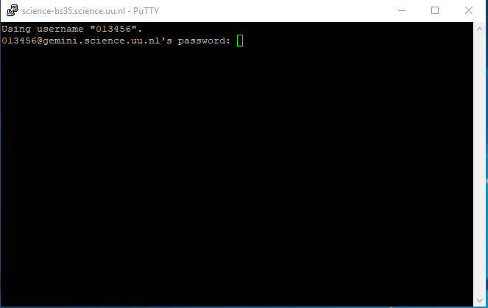

Type ssh [your-subsite]@webtech.science.uu.nl and enter your password, the default is ‘webtech’

**Please note: When you first log in use the ‘passwd’ command to change your password from the default**

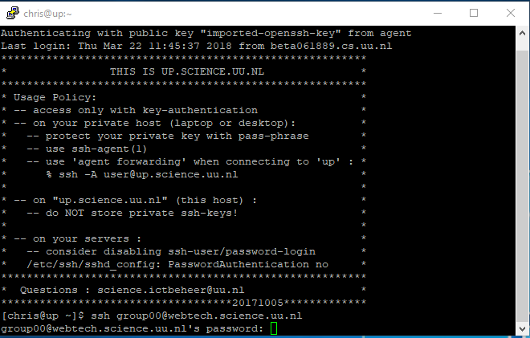

Open a file in the nano text editor by typing nano main.js 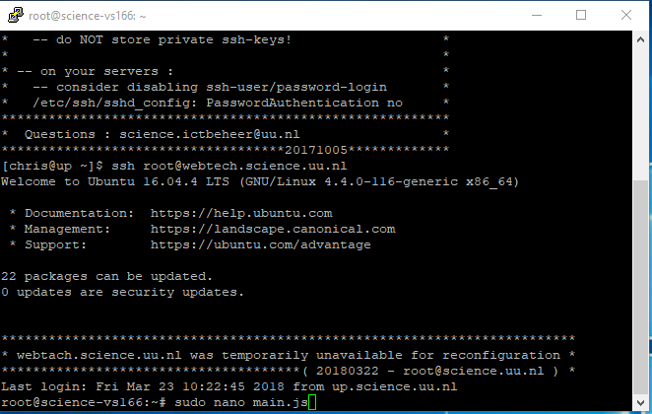

Paste the example code sent in the announcement, change the port to the one defined for your group. Use Ctrl+X to close, yes to save changes and ENTER to save.

**ONLY USE THE PORT FOR YOUR GROUP, NOT ANYONE ELSE’S**

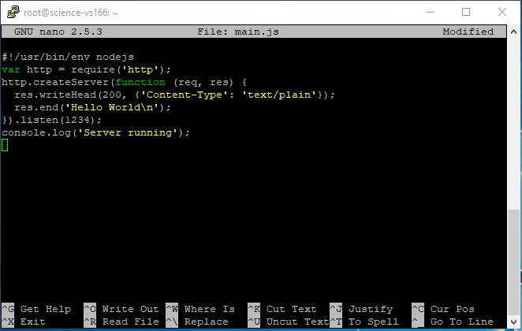

Run the file using “pm2 start main.js”. If you change the app then you’ll need to restart it.

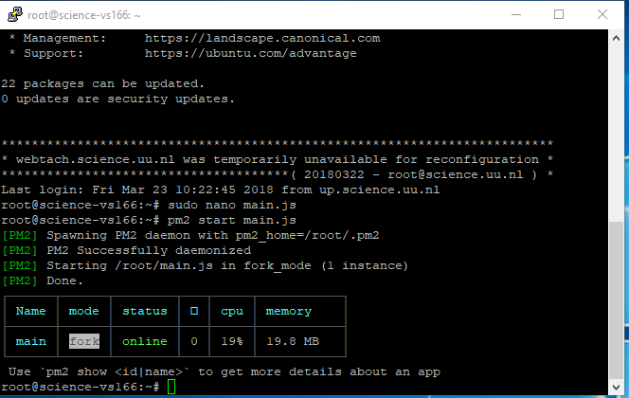

If you open a web browser and point it to http://webtech.science.uu.nl/[your-subsite] then you should see the ‘hello world’ text.